# Configure 3rd Party API

## Product Reviews Service from Bazaarvoice

1. In the Publisher Portal, click on APIs 🡪 Add API. In the dialog, enter values as shown below. The 3rd party url in this case will be [http://api.bazaarvoice.com/data/reviews.xml?apiversion=5.4&passkey=aelgaok3a8eyu37x5ehinkwah&Filter=ProductId:{bvCode}&Include=Products&Stats=Reviews](http://api.bazaarvoice.com/data/reviews.xml?apiversion=5.4&passkey=aelgaok3a8eyu37x5ehinkwah&Filter=ProductId:%7bbvCode%7d&Include=Products&Stats=Reviews)

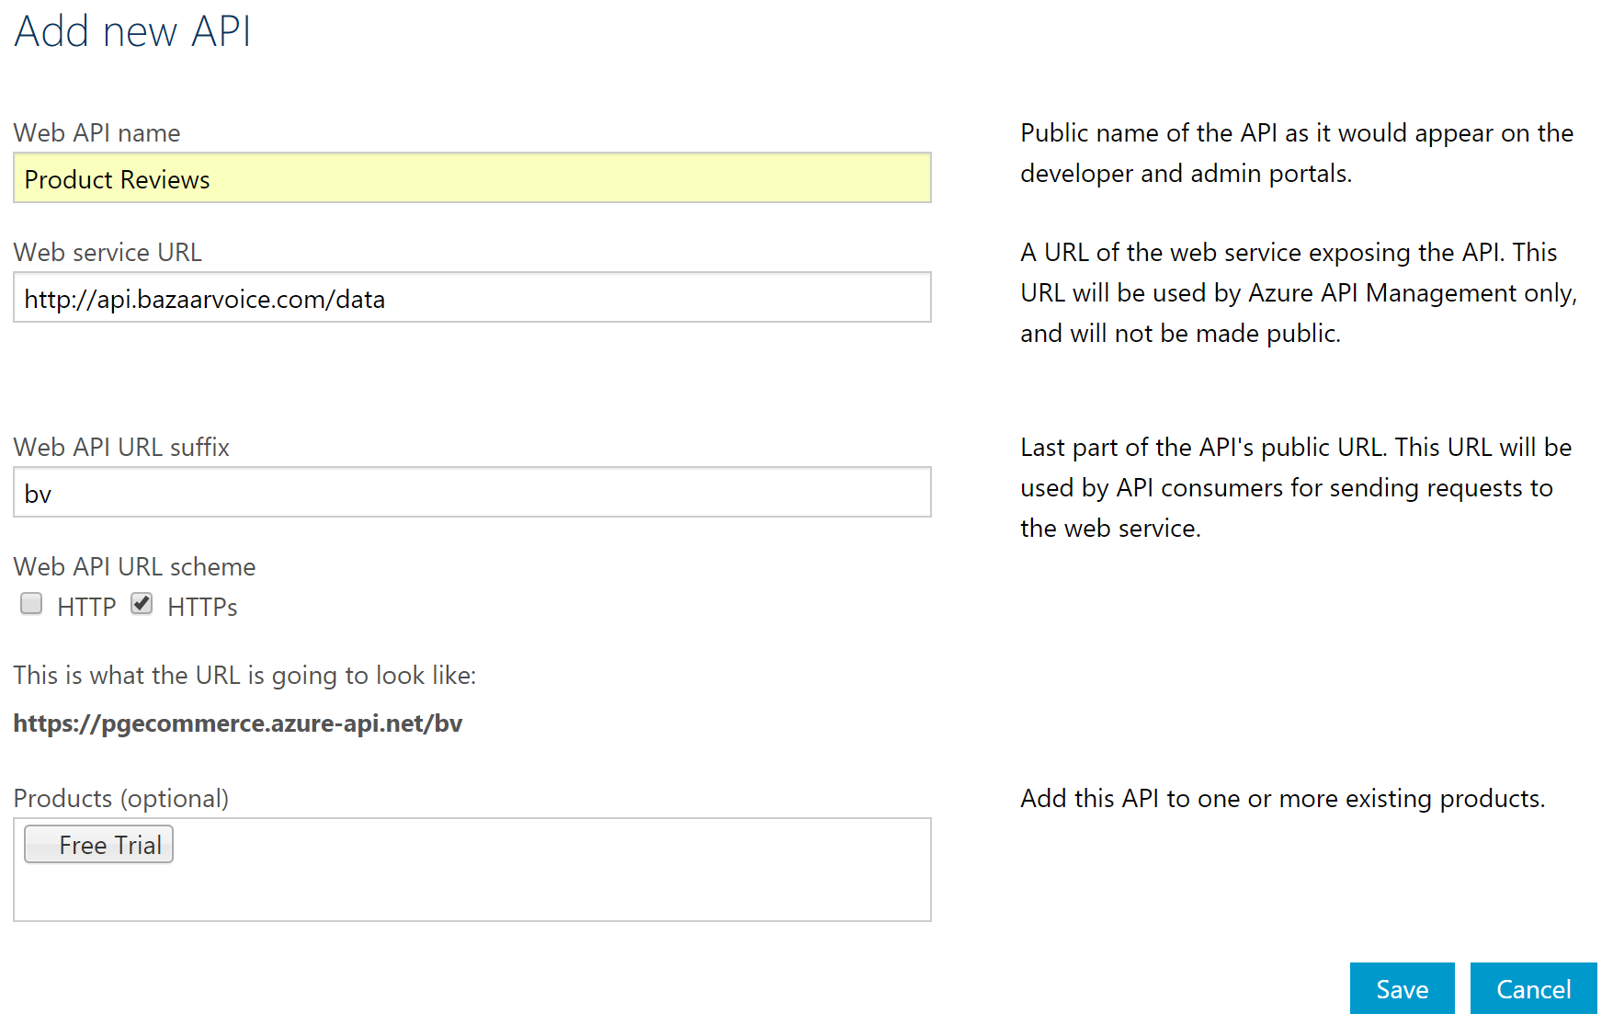

1. Once the API is created, proceed to add the service operations.

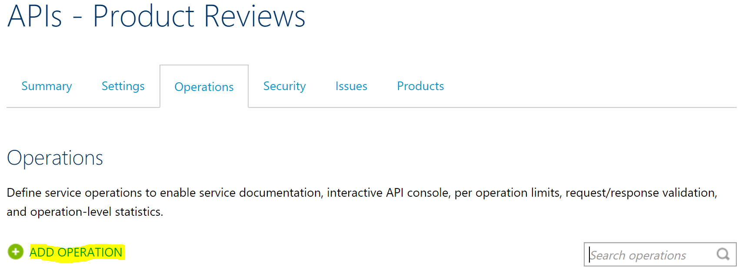

1. Specify the operation signature as shown below and with the following values:

URL Template 🡪 **/reviews/{bvCode}**

Rewrite URL Template 🡪 **/reviews.xml?apiversion=5.4&passkey=aelgaok3a8eyu37x5ehinkwah&Filter=ProductId:{bvCode}&Include=Products&Stats=Reviews**

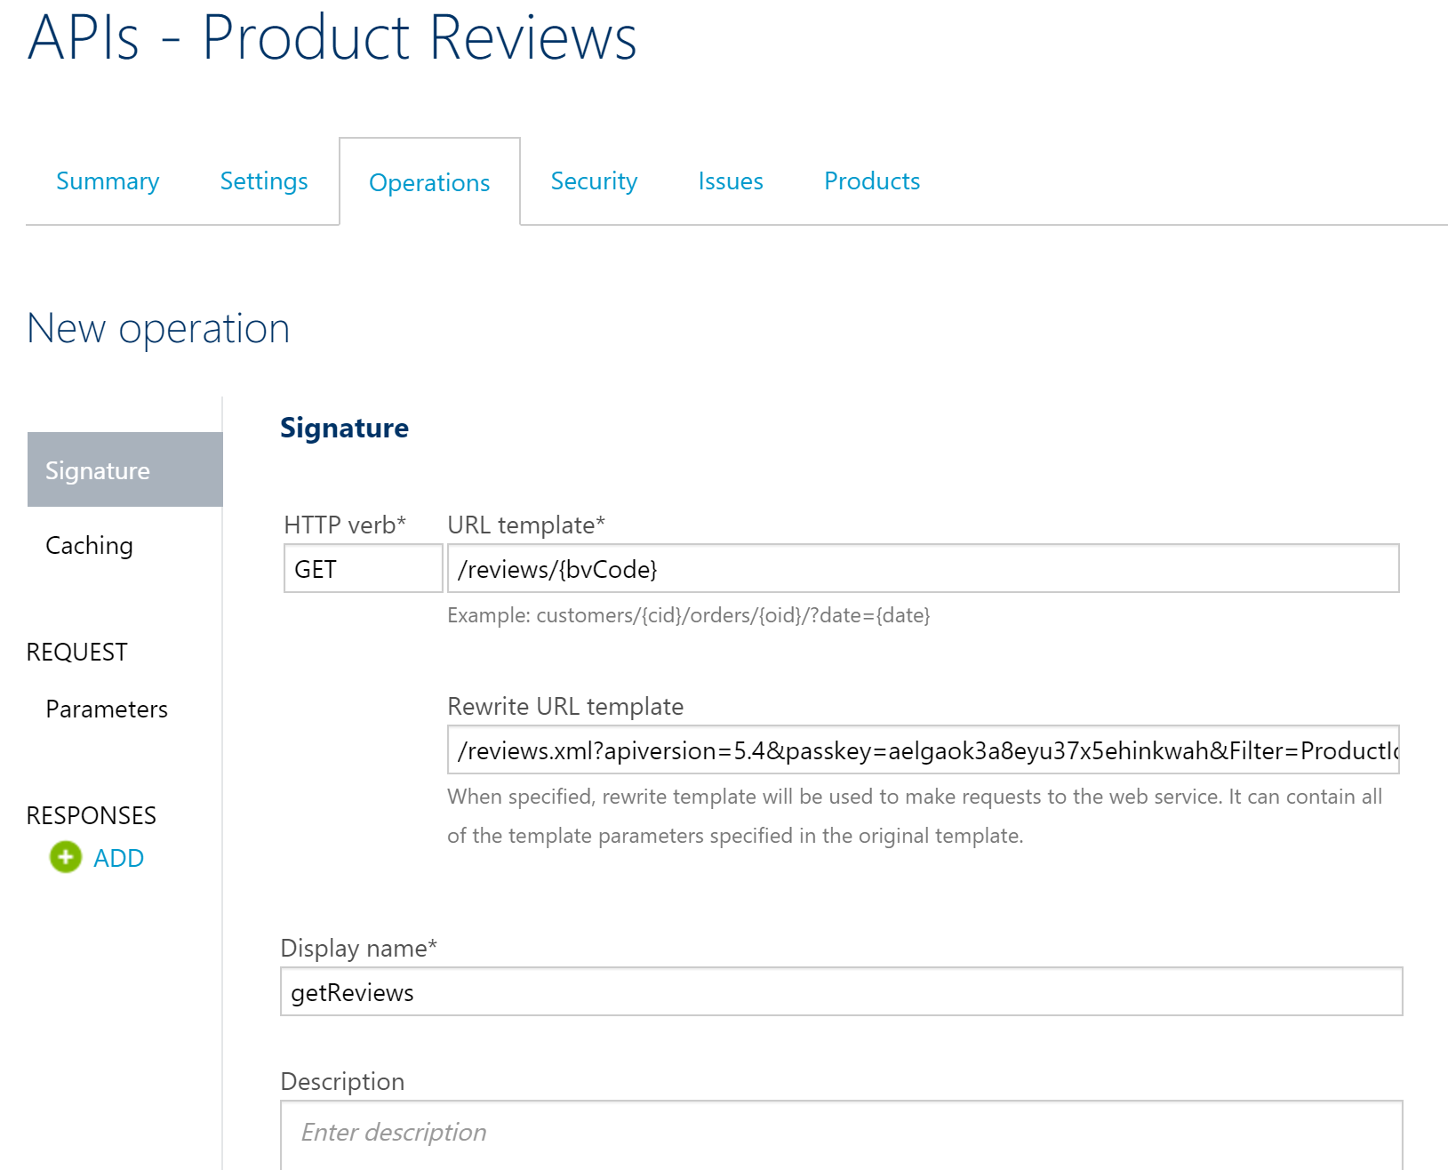

1. Note that the URL template parameter {bvCode} specified in the previous step is automatically created:

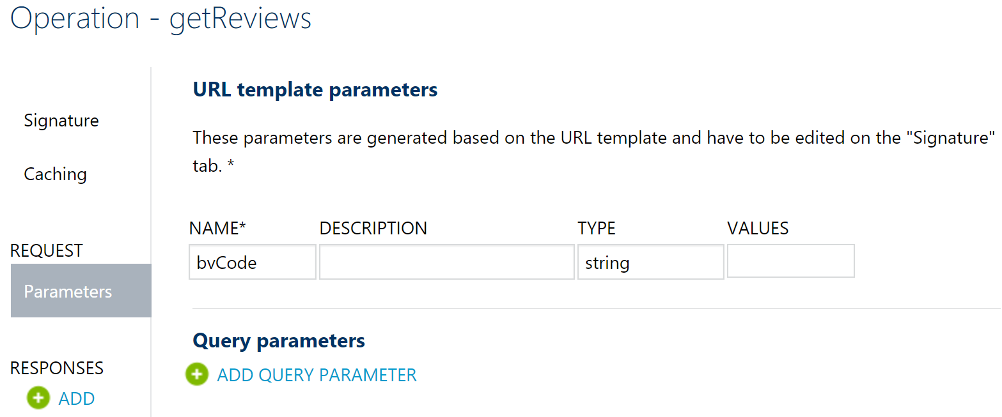

1. Verify that the newly configured API works by accessing <https://pgecommerce.azure-api.net/bv/reviews/000080265628>.

# References